Certifications
AWS Certified Solution Architect - Associate
AWS Certified Cloud Practitioner

Education

About me:
I am a junior DevOps consultant with a passion for IT. I can quickly assimilate new ideas, concept and cutting-edge technologies whilst demonstrating a logical and analytical approach to solving problems and issues. I possess excellent interpersonal and communication skills and the ability to develop and maintain positive internal and external relationship. I am interested in software development and cloud technologies, example of project I have contributed can be found at https://github.com/Zhal73 and https://simmer.io/@zhal73
My website : https://domenico-gagliano.net

Work Experiences:
April 2021 – Present
Incopro
Junior DevOps Engineer
I am responsible for to buy, maintain and check of the proxies used by company’s data collection software Talisman.
My duty is to make sure the proxies are always up and running, maintain contacts with the proxy providers when problems make the proxies unreachable and to increase the proxy poll according to the needs of specific regions.
I use Ansible to install the necessary software to the proxies so they can be used by Talisman.

July 2020 – March 2021
QA Consulting
DevOps Consultant
Training as DevOps Consultant, I contributed to three projects where I gained competence in CD/CI with tools such as Jenkins, Ansible, Docker, Kubernetes. I gained competences in Cloud technologies and I was able to use GPC and Amazon AWS services. I became confident with Agile and SCRUM methodologies, in my last project other than take care of the containerization of the application with Docker and Kubernetes, I also act as SCRUM Master to lead daily stand-up meeting.

April 2013 – July 2020
Arriva Bus UK
London: 2013 – 2017; Maidstone: 2017 – 2020
Bus Driver
I improved my customer service skill and I gained ability to work in a high-pressure environment. During my service I maintained excellent attendance record and I helped the company to meet industry standard by daily checking vehicles for maintenance needs and reported concern to superior. I provided training and mentoring for new driver by performing induction, route learning and continuous mentoring.
operations. I completed store opening and closing procedures, including setting up registers and checking products.

Contact
Domenico Gagliano
Junio DevOps Engineer

Address
2 Egerton Road, Maidstone, Kent
ME14 2QY
Phone
07816765605
Email
gaglianodomenico@gmail.com

2016 – Current
BSc Computing and IT
Open University
2016 – 2020
Diploma of Higher Education in Computing and IT
Open University
2016 – 2018
Certificate of Higher Education in Computing and IT
Open University

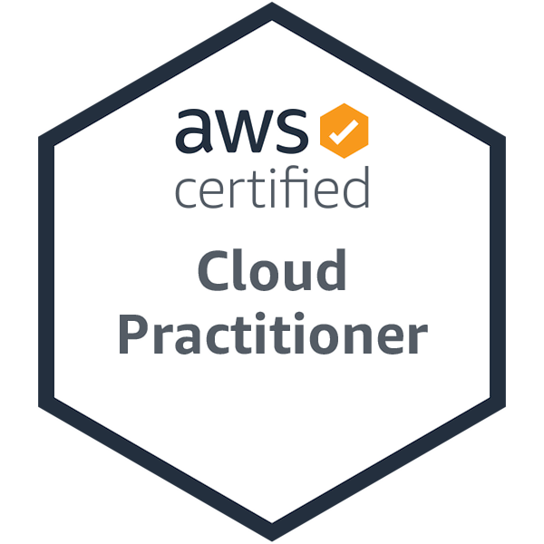


Skills and Knowledge
May 2011 – April 2013
Starbuck UK
London
Barista (2011) - Shift Supervisor (2012 – 2013)
I gained customer service skill, I learnt to apply health and safety procedure during shifts, I was able to establish effective employee schedules and delegate tasks to take advantage of individuals abilities, I evaluated employee skills and knowledge regularly, providing hands-on training and mentoring to individual with lagging skills. I dealt with customer to address customer questions and concern. I helped the store manager in meeting standard service and quality in daily operations. I completed store opening and closing procedures, including setting up registers and checking products.

2007 – 2010
Self-Employer
Palermo - Italy
Freelance IT technician
I provided technical support for private customer to address problem with computers, printers, and other peripheral devices. My support included network installation, operating system patch and update, malware and virus remotion, hardware and software upgrading and clarify customers’ technical concerns using clear terms to non-technical individuals to promote better understanding.

2004 – 2007
Informatica Commerciale
Palermo - Italy
IT technician
I started with minor assignments which included hardware and software setup, network installation and sales. In a short time, I improved my knowledge in Cisco routers, and I was able to set up small business environment. I gained knowledge in Linux and Apache Web server, and I contribute to set up new web sites for customers. I gained customer services’ skills and I improved my team working attitude.

1999 – 2003
Talent School
Palermo
Owner (Teacher/Trainer)
I was responsible for ECDL courses and examination sessions. I organised, managed and basic IT courses which included MS Office suite, computer fundamental and Internet browsing in classes of about 15 people. I improved my organisation skills as well as my customer services skill, I was able to teach concept to people with scarce or absent technical background.

Python
Java
C/C++
C#
Amazon AWS
Google GCP
Git
HTML
MySQL
Linux
Jenkins
Docker
Kubernetes
CI/CD
Shell Scripting
Windows OS
MacOS
Customer Services
Team Working

Italian: Mother Tongue
English: Fluent

Music: listen and playing, I play Saxophone and I am learning the Keyboard.
Football and Motor sports
Martial Arts (Judo)
I like to meet and learn from different people.

Hobbies
Languages

